**A PROJECT REPORT ON**

**Online Article & Discussion Platform for CSE Students**

**CSE Hankers**

**By**

**Jwalit Shah (CE121) (18CEUOS057)**

**B. Tech CE Semester - VI**

**Subject: Object Oriented Software Engineering**

**Guided By:**

**Prof. Mrudang T. Mehta**

**Associate Professor**

**Dept. Of Computer Engineering**

**Prof. Jatayu H. Baxi**

**Assistant Professor**

**Dept. Of Computer Engineering**



**Faculty of Technology**

**Department of Computer Engineering**

**Dharmsinh Desai University**



**Faculty of Technology**

**Department of Computer Engineering**

**Dharmsinh Desai University**

**CERTIFICATE**

This is to certify that the practical / term work carried out in the subject of **Object Oriented Software Engineering** and recorded in this journal is the

bonafide work of

**Jwalit Shah (CE121) (18CEUOS057)**

of B.Tech semester **VI** in the branch of **Computer Engineering** during the academic year **2020-2021**.

Prof. Mrudang T Mehta

Associate Professor,

Dept. of Computer Engg.,

Faculty of Technology,

Dharmsinh Desai University, Nadiad

Prof. Jatayu H. Baxi

Assistant Professor,

Dept. of Computer Engg.,

Faculty of Technology,

Dharmsinh Desai University, Nadiad

Dr. C. K. Bhensdadia,

Head,

Dept. of Computer Engg.,

Faculty of Technology,

Dharmsinh Desai University, Nadiad

**Table of Contents**

**Abstract**4

Purpose 4

Scope 4

**Introduction**5

Brief Introduction 5

Technology/Platform/Tools used 5

**Software Requirements Specification - SRS**6

Functional Requirements 6

Common Functional Requirements 6

R.1 Administrator 7

R.2 End Users 7

**Design**10

Data flow Diagram - Level 0 10

Class Diagram 11

State Diagram 12

Use case Diagram 13

Sequence Diagram 14

Activity Diagram 15

ER Diagram 16

Data Dictionary 17

**Implementation Detail**19

Modules 19

Function prototypes which implements major functionality. 20

Testing 20

Log in to the system. 20

Publish Article 21

Like/Dislike Article. 21

**Screenshots**22

**Conclusion**31

**Limitation and Future Extensions**32

Limitations 32

Functionalities not implemented 32

Possible future extensions 32

**Bibliography**32

# **Abstract**

This CSE Hankers System is a web application that provides the platform for users to publish and manage their articles. Users can also ask questions related to the field and also upvote the articles or answers by giving likes or comments to it.

## **Purpose**

The purpose of the Software Requirements Specification is to outline the requirements for the “Online Article & Discussion Platform for CSE Students”. This product will be built on Dotnet core and SQLite server using provided tech-stacks. It will be operating system independent and accessible with any standard compliant browser having python installed on that local machine.

## **Scope**

“CSE Hankers” is intended for Computer Science related community which helps them to find the certain related topics via Blogs/Articles written by other person and also, they can have a Questionnaires & give answers on the platform which makes platform kind a Forum for discussion and helps them to find their way.

# 

# **Introduction**

## **Brief Introduction**

The “CSE Hankers” is a web application for users to get the way out in their field when they get stuck. The system mainly works around two users, End Users and one Admin user. Users can Register and login to the system. Users can View the articles of the users to whom the user follows. Users can also create, update and delete their Articles. Users can ask Questions to the forum. Upon finding the content useful users can give like or comment. And upon seeing pirated content they can report the content. System checks all the corner cases for authentication, authorization of the users, validation of input data, duplication of data and gives appropriate error response messages according to the situation.

## **Technology/Platform/Tools used**

**Technology :**

* Dot net core framework
* SQL Server database.
* Bootstrap

**Platform :**

* Windows

**Tools :**

* Visual Studio

# **Software Requirements Specification - SRS**

Total 2 type of users are there in system:

1. User
2. Admin user

## **Functional Requirements**

User wise defined Functional Requirements.

## **Common Functional Requirements**

**1. Login**

Description: Login to the Administrator dashboard

Input: User credentials

Output: Appropriate status message and Redirection

**2. Logout**

Description: Logout from the currently logged in session

Input: User selection

Output: Success message and Redirect to login page

**3. Forgot Password**

Description: Reset the password if the password is forgotten.

Input: User Selection

Output: Redirection to Login page after resetting password.

## **R.1** **Administrator**

**R.1.1 Accept / Discard the Report Content request**

Description: Administrator can Discard the Reported Content request or can delete the content by accepting the request.

Input: Article details

Output: Response message

**R.1.2 View Contents of platform**

Description: All of the contents (etc. Questions, Articles, Answers ) can be viewed according to the user selection criteria

Input: User selection

Output: Details of Articles

**R.1.3 Statistical data**

Description: Some statistical data can be viewed of the platform

Input: User selection

Output: Statistical Details

## **R.2** **End Users**

**R.2.1 Register**

Description: Register the self to the platform.

Input: User details and credentials

Output: Appropriate status message and Redirection

**R.2.2 Follow users**

Description: Any user can follow the other user

Input: User selection

Output: Success message

**R.2.3 Publish Articles**

Description: User can publish the articles to all other users

Input: Article details

Output: Response message

**R.2.4 View Articles**

Description: Articles can be viewed according to the user selection criteria

Input: User selection

Output: Details of Articles

**R.2.5 Update/Delete Articles**

Description: User can Update and Delete the articles

Input: Article details & User selection

Output: Response message

**R.2.6 Comment on the Articles**

Description: User can give comments on the articles

Input: User selection & comment description

Output: Response message

**R.2.7 Ask Questionnaires**

Description: Users can put questions on the platform.

Input: Question description

Output: Success message

**R.2.8 Modify and Delete asked Questions**

Description: User can modify and delete the asked questions on the platform asked by the user itself.

Input: User selection and Questions description

Output: Success message

**R.2.9 Like Articles/ Answers**

Description: User can give like to their favorite articles/ answers to the question

Input: User selection

Output: Success notification

**R.2.10 Report for Contents**

Description: Users can request the Administrator to perform certain actions on selected Content requests like (selected content can be Article, answer or question).

Input: Article details

Output: Response message

# 

# **Design**

## **Data flow Diagram - Level 0**

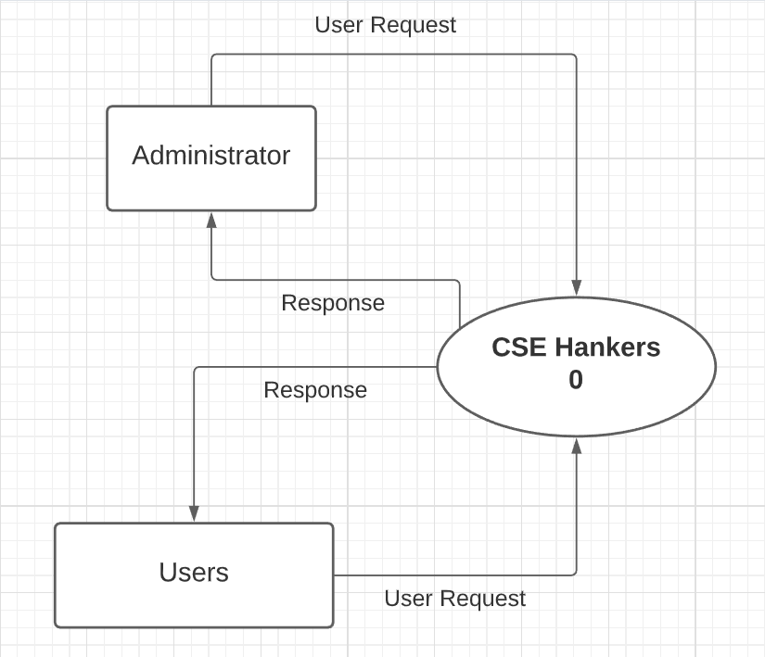

## **Class Diagram**

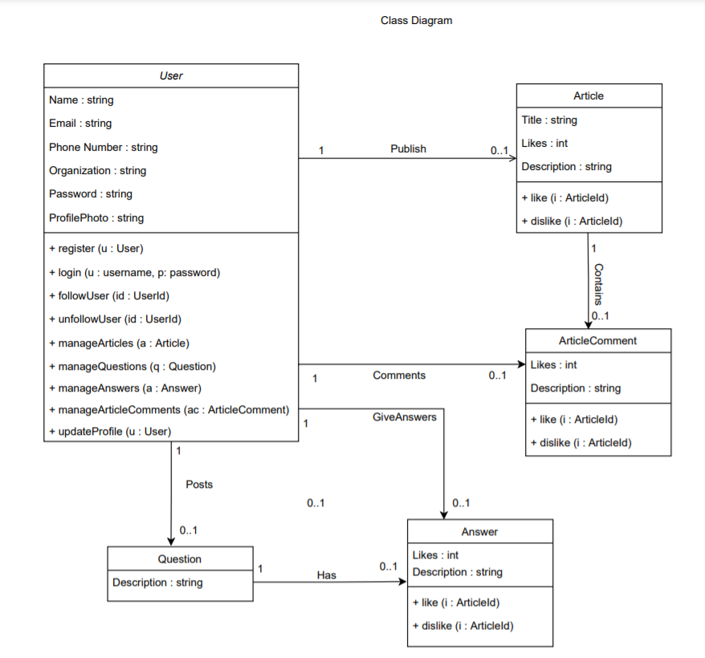

## **State Diagram**

**Post Comment**

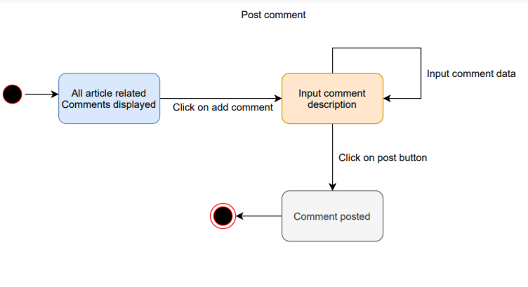

**Like/ dislike content**

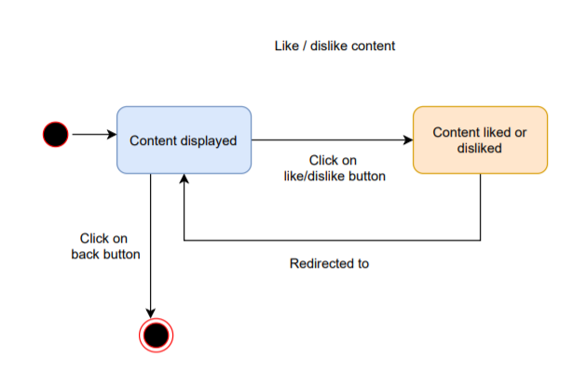

## **Use case Diagram**

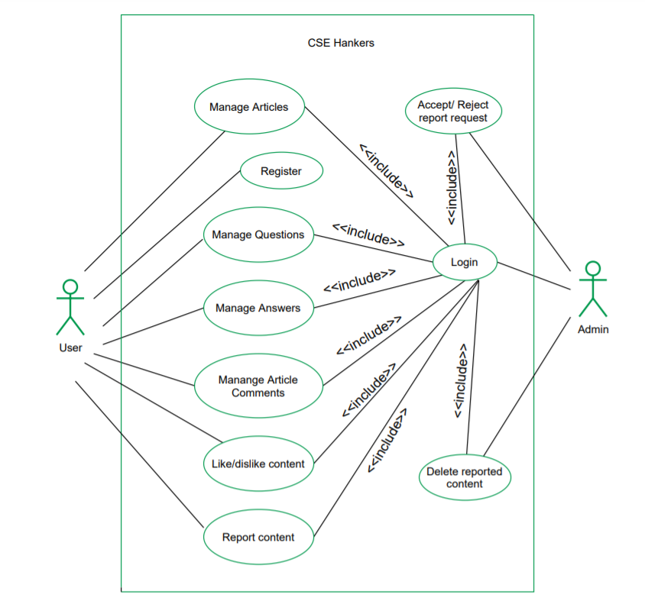

## **Sequence Diagram**

## 

## **Activity Diagram**

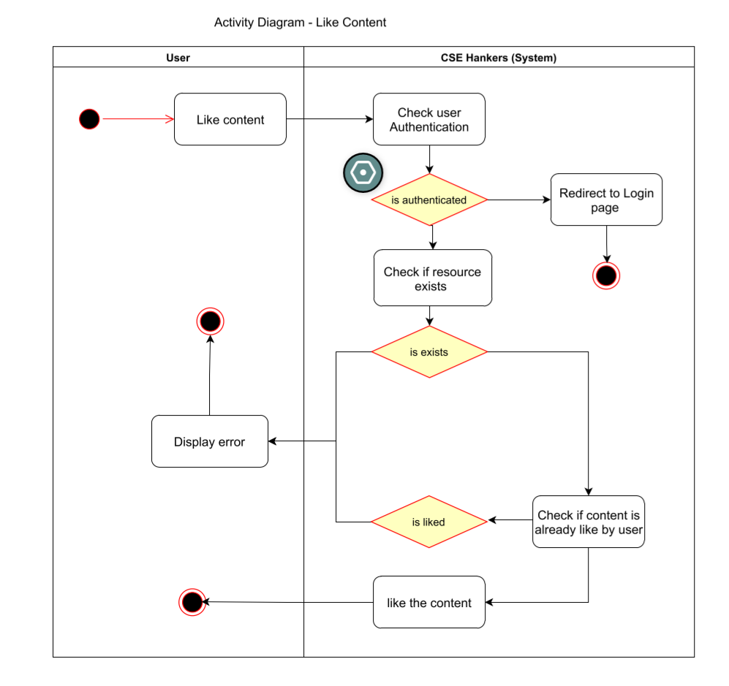

## 

## 

## **ER Diagram**

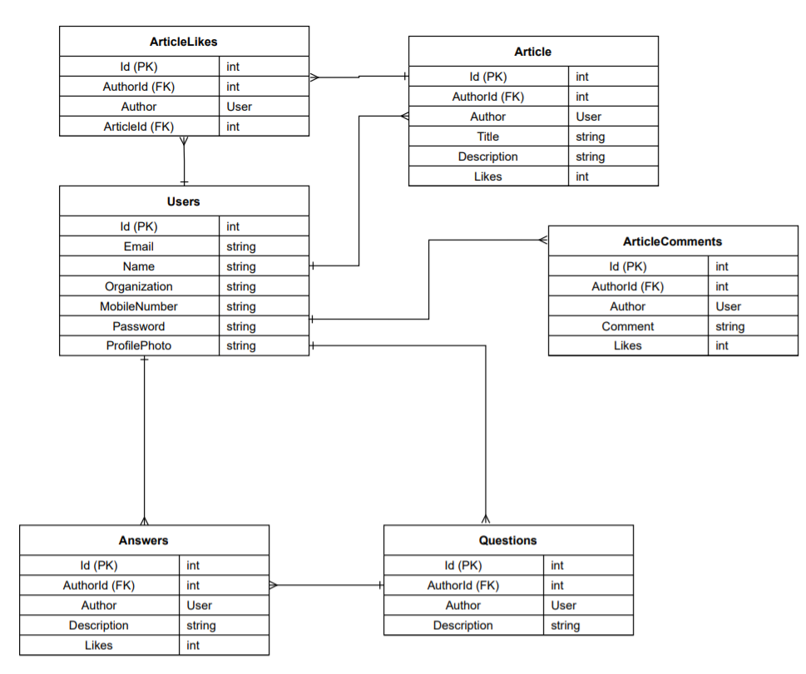

## 

## 

## **Data Dictionary**

### **User**

|  |  |  |  |  |  |  |
| --- | --- | --- | --- | --- | --- | --- |
| **No** | **Field name** | **Data type** | **Required** | **Unique** | **PK / FK** | **Ref. Table** |
| 1 | UserId | int | true | true | PK | - |
| 2 | Email | string | true | true | - | - |
| 3 | Name | string | true | false | - | - |
| 4 | Password | string | true | false | - | - |
| 5 | PhoneNumber | int | true | false | - | - |
| 6 | Organization | string | true | false | - | - |
| 7 | ProfilePhoto | string | true | false | - | - |

### 

### **Article**

|  |  |  |  |  |  |  |
| --- | --- | --- | --- | --- | --- | --- |
| **No** | **Field name** | **Data type** | **Required** | **Unique** | **PK / FK** | **Ref. Table** |
| 1 | ArticleId | int | true | true | PK | - |
| 2 | AuthorId | int | true | false | FK | User |
| 3 | Title | string | true | false | - | - |
| 4 | Description | string | false | false | - | - |
| 5 | likes | int | false | false | - | - |

### 

### **ArticleComments**

|  |  |  |  |  |  |  |
| --- | --- | --- | --- | --- | --- | --- |
| **No** | **Field name** | **Data type** | **Required** | **Unique** | **PK / FK** | **Ref. Table** |
| 1 | ArticleCommentId | int | true | true | PK | - |
| 2 | AuthorId | int | true | false | FK | User |
| 3 | ArticleId | int | true | false | FK | Article |
| 4 | Description | string | false | false | - | - |
| 5 | likes | int | false | false | - | - |

### 

### **Answers**

|  |  |  |  |  |  |  |
| --- | --- | --- | --- | --- | --- | --- |
| **No** | **Field name** | **Data type** | **Required** | **Unique** | **PK / FK** | **Ref. Table** |
| 1 | AnswerId | int | true | true | PK | - |
| 2 | AuthorId | int | true | false | FK | User |
| 3 | QuestionId | int | true | false | FK | Question |
| 4 | Description | string | false | false | - | - |
| 5 | likes | int | false | false | - | - |

### 

### **Questions**

|  |  |  |  |  |  |  |
| --- | --- | --- | --- | --- | --- | --- |
| **No** | **Field name** | **Data type** | **Required** | **Unique** | **PK / FK** | **Ref. Table** |
| 1 | QuestionId | int | true | true | PK | - |
| 2 | AuthorId | int | true | false | FK | User |
| 4 | Description | string | false | false | - | - |

### **ArticleLikes**

|  |  |  |  |  |  |  |
| --- | --- | --- | --- | --- | --- | --- |
| **No** | **Field name** | **Data type** | **Required** | **Unique** | **PK / FK** | **Ref. Table** |
| 1 | ArticleLikeId | int | true | true | PK | - |
| 2 | AuthorId | int | true | false | FK | User |
| 3 | ArticleId | int | true | false | FK | Article |

# 

# **Implementation Detail**

## **Modules**

Total modules :- 2

1. **Account Module :-**

This module manages operations related to users’ accounts like login, signup and forgot password. Existing users can login to the system by providing their email-id and password. New users can create their account by providing the required details. Users can follow other users to see their articles. And also can unfollow the user.

1. **Article Module :-**

This module manages operations related to articles. Users can publish new articles. They can view a list of their own published articles.They can update & delete their own published articles. Users can see other user’s articles by following that user. And users can provide their feedback by providing comments and likes to the articles. Users can report the content. Users can dislike the articles if they don’t like them.

## **Function prototypes which implements major functionality.**

* Public void register (User user)
* Public void login (string username, string password)
* Public void followUser (int userId)
* Public Article addArticle (Article article)
* Public ArticleComment postComment (ArticleComment articleComment)
* Public ArticleComment[] getArticleComments (int articleId)
* Public Article[] getAllArticles ()
* Public void likeArticle (int articleId)

## **Testing**

Unit testing of each module was done after successfully completing the module. Each module was tested individually before integrating them with the whole system.

After integrating each module with the system, integration testing was done in order to check if modules are working properly together. After completing all integrations, black-box testing of the whole system was carried out to ensure the system works in a correct manner.

**Black box testing of Major functions of the system**

### **Log in to the system.**

**Case 1 :** Invalid Username or password entered by the user.

**Output :** Error message on the screen saying “Invalid credentials”

**Case 2 :** Valid credentials.

**Output :** The user is redirected to the Dashboard page.

### 

### **Publish Article**

**Case 1 :** Some of required fields missing in input.

**Output :** Model validation errors will be displayed to the user.

**Case 2 :** All input data are valid.

**Output :** Article published successfully.

### **Like/Dislike Article.**

**Case 1 :** User is not logged in.

**Output :** Redirected to the login page with error message “Please login..!”.

**Case 2 :** If an article is already liked.

**Output :** Error message will be displayed, “Article already liked.!”

**Case 3 :** If an article is already disliked.

**Output :** Error message will be displayed, “Article not liked yet.!”

**Case 4 :** If an article is not liked and like operation is performed.

**Output :** Success message “Article liked” shown and like symbol color changes.

# 

# **Screenshots**

1. **Login page - with error messages**

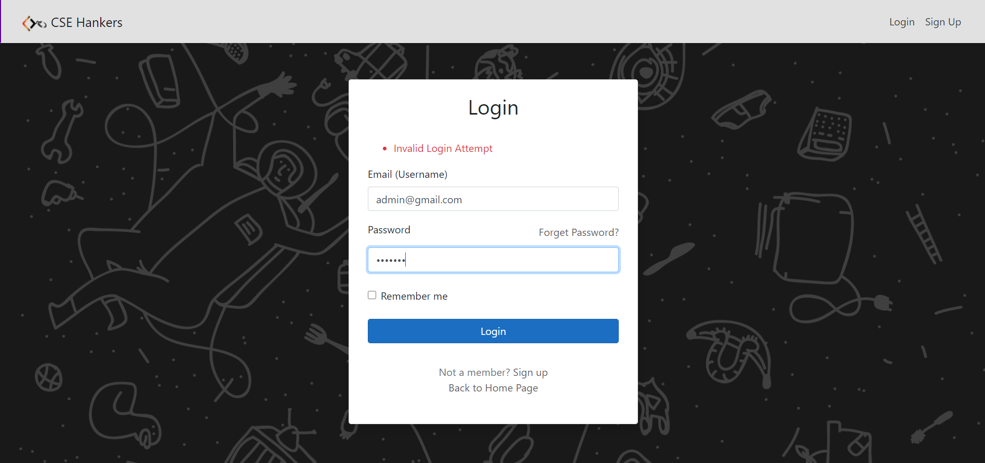

1. **Registration page- with error messages**

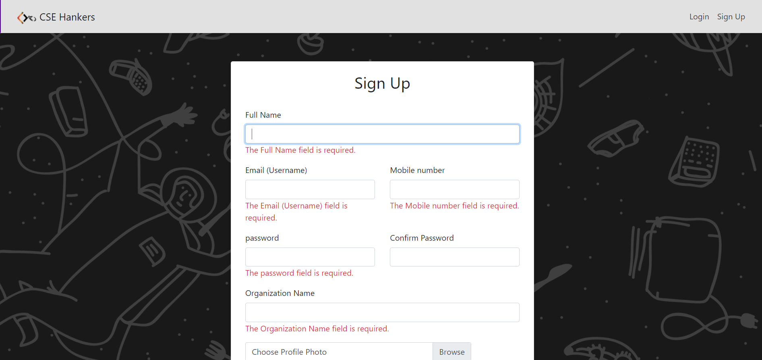

1. **Dashboard**

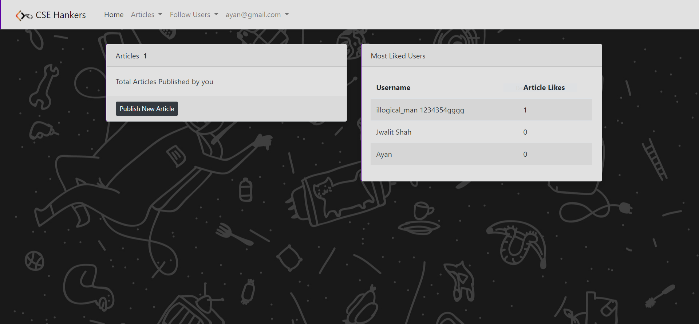

1. **Publish article**

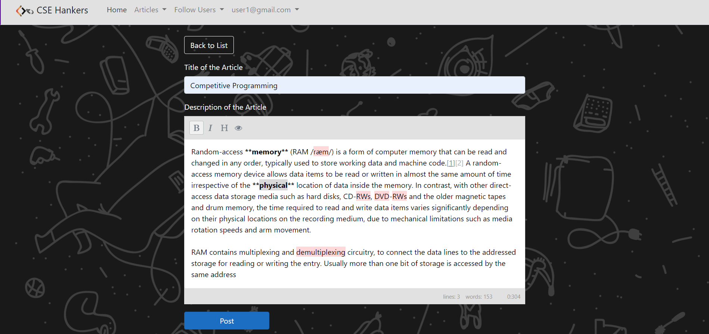

1. **Pagination**

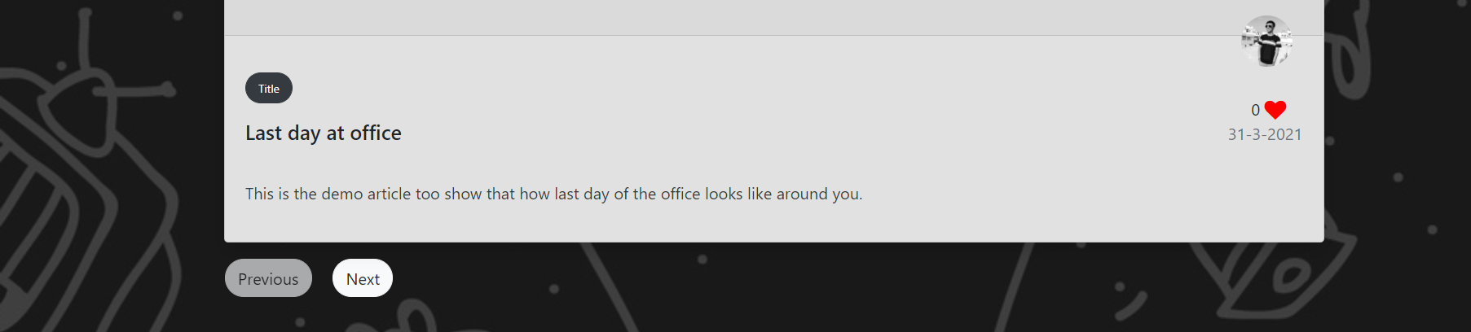

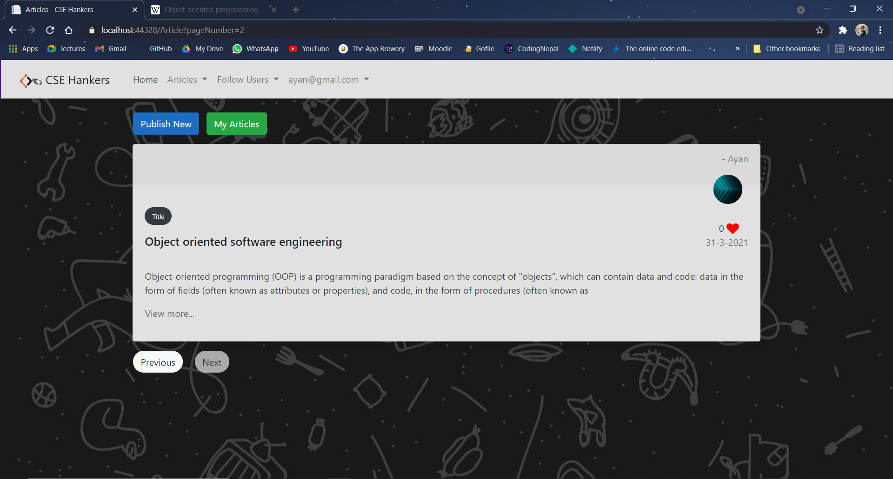

1. **View article details & add comment**

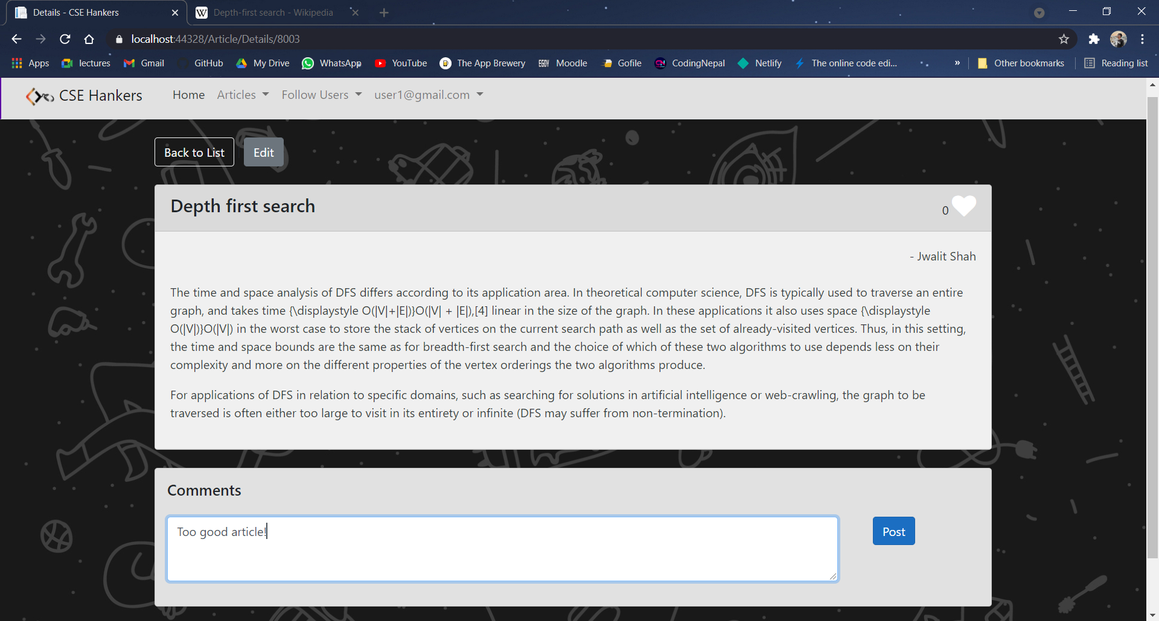

1. **View comments**

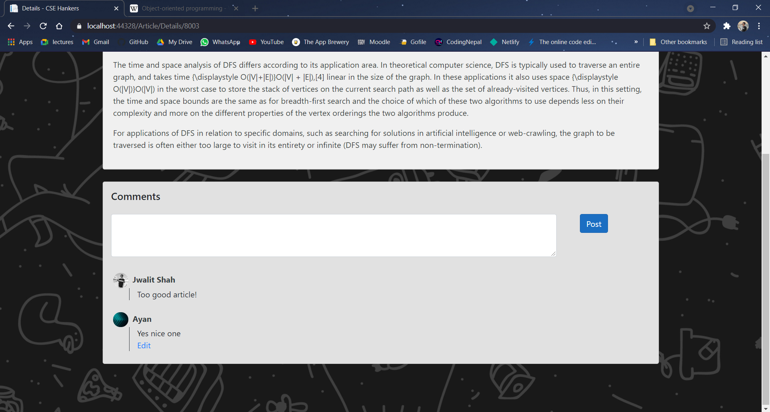

1. **Edit comment**

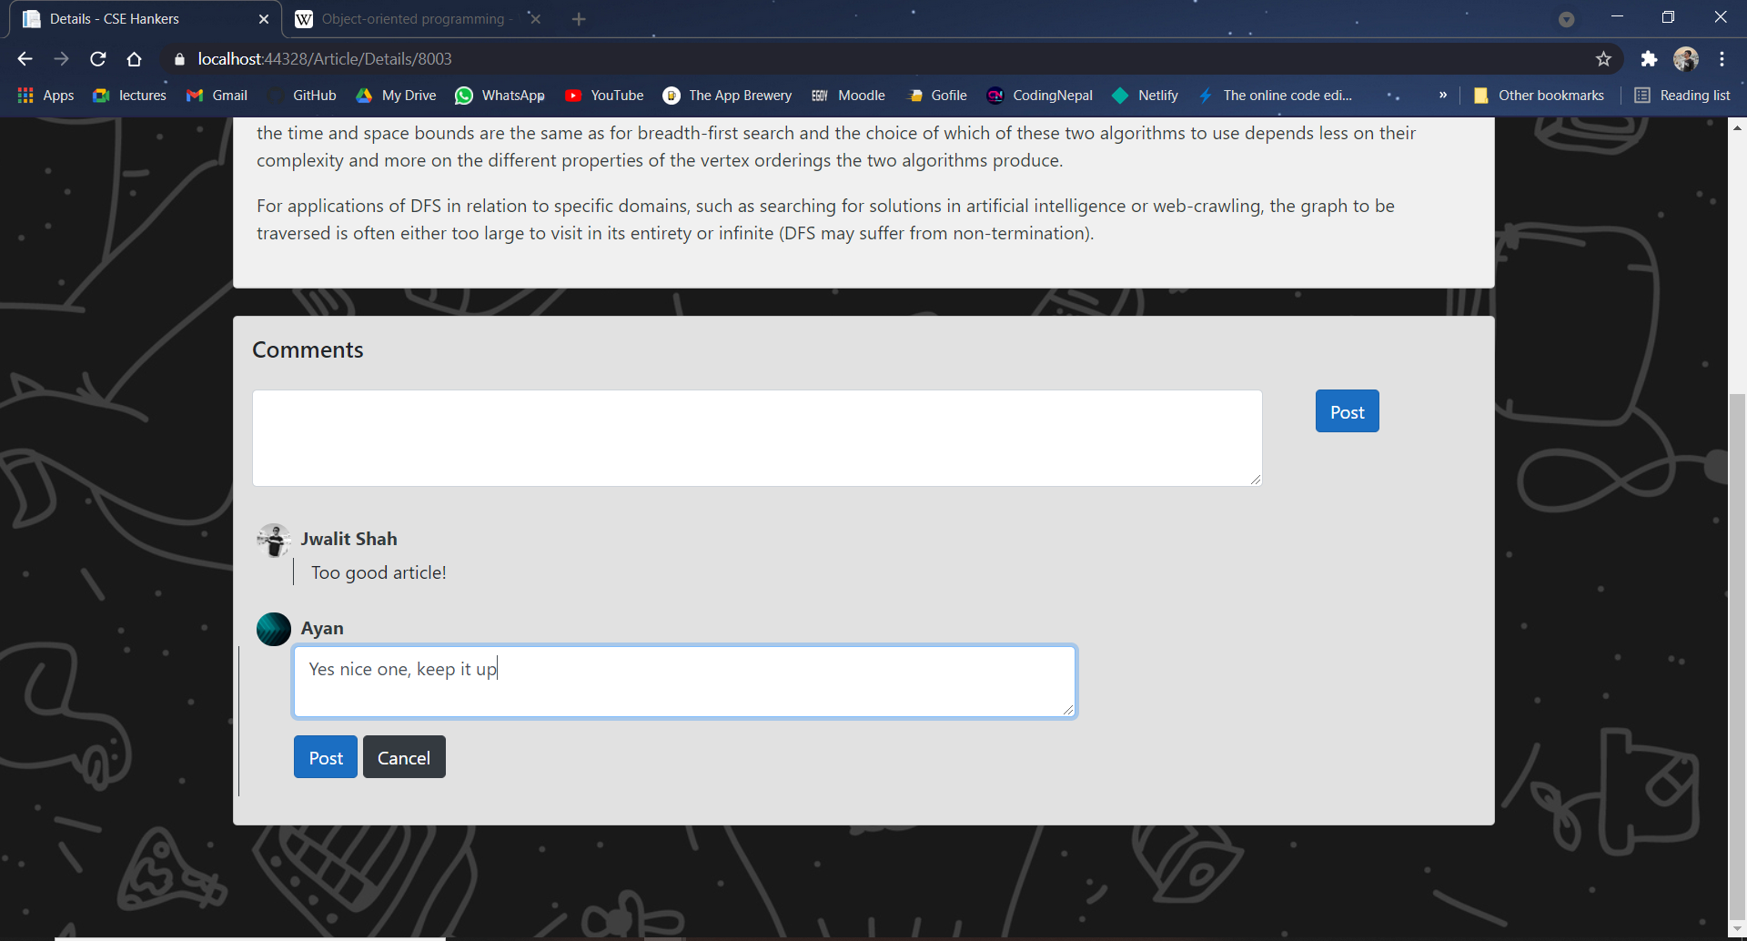

1. **Unfollowed Users that are on platform**

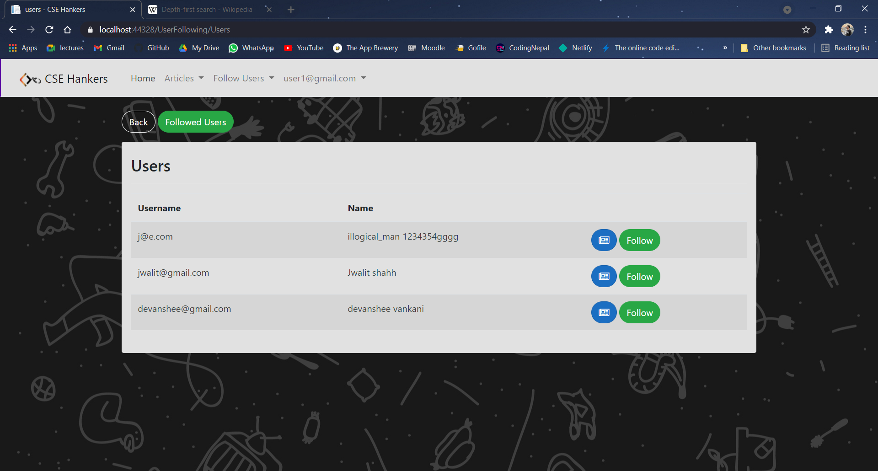

1. **My Followed users**

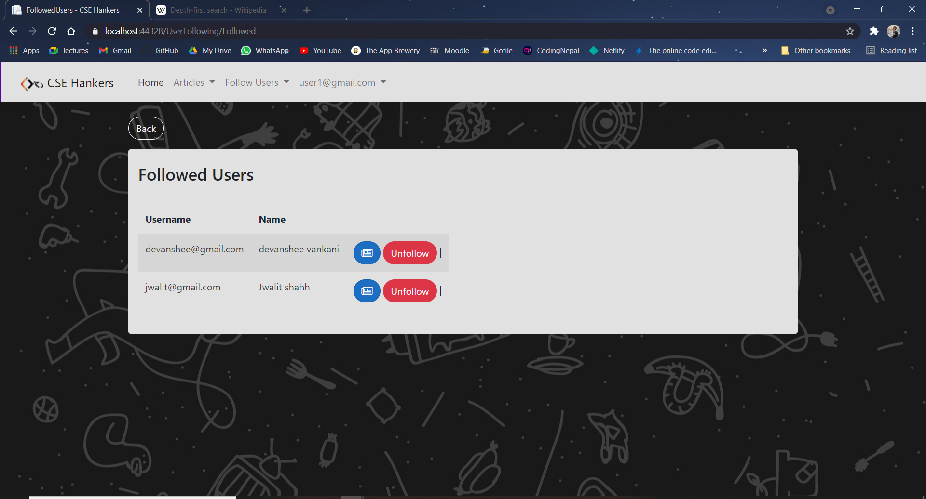

1. **Edit article**

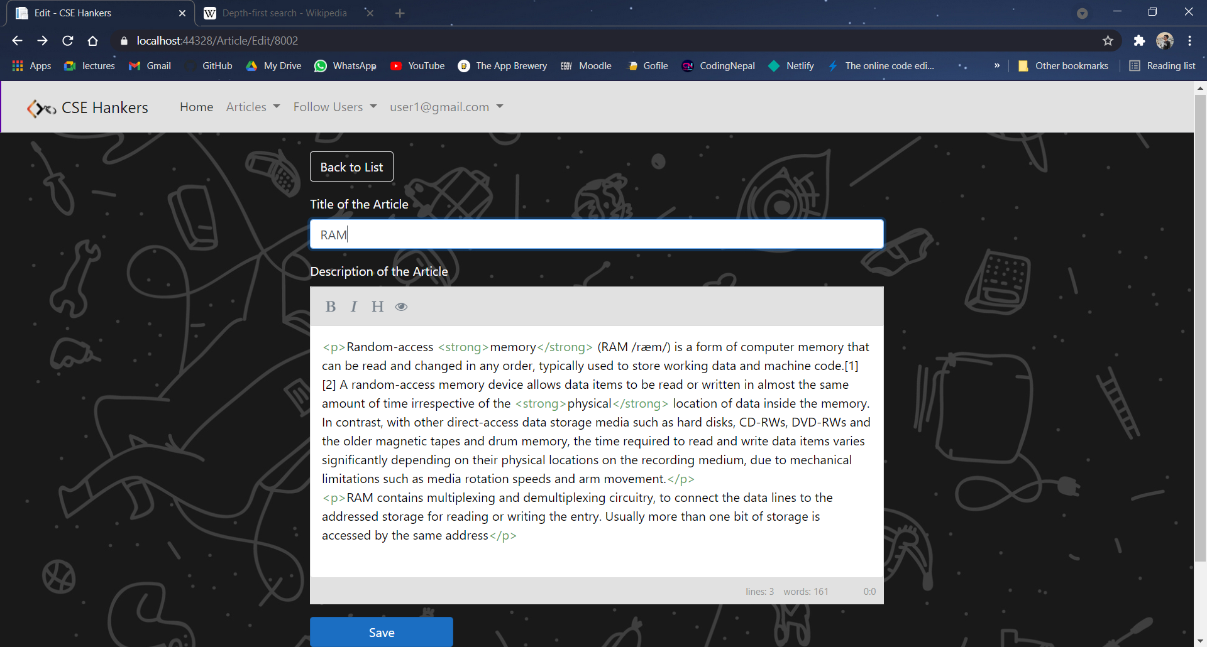

1. **Delete article**

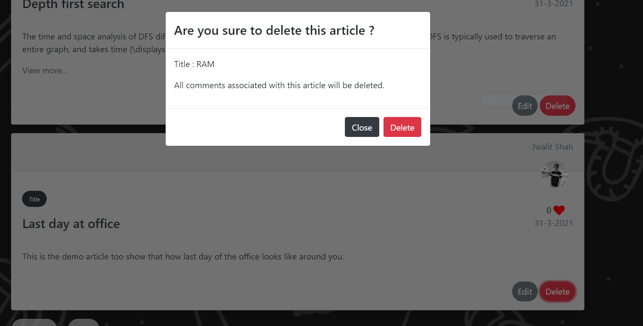

1. **Like article**

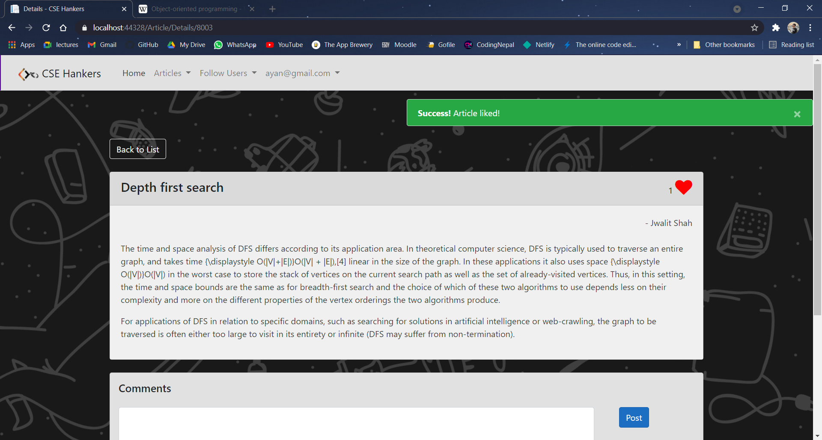

1. **My article list**

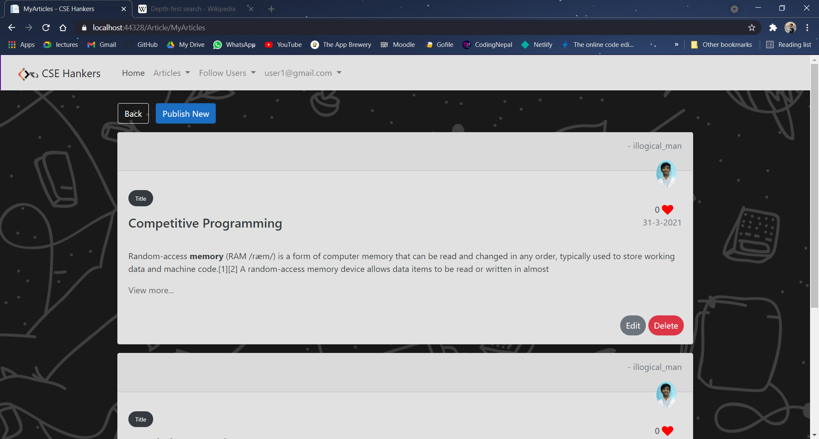

1. **View profile**

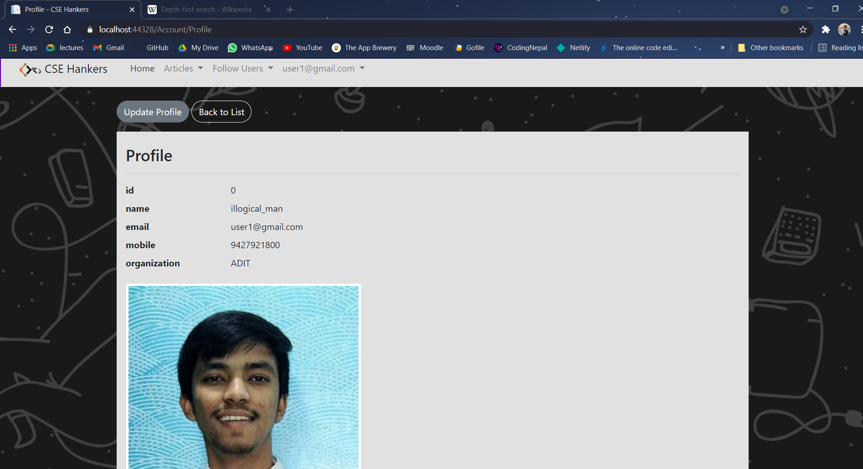

1. **Update profile**

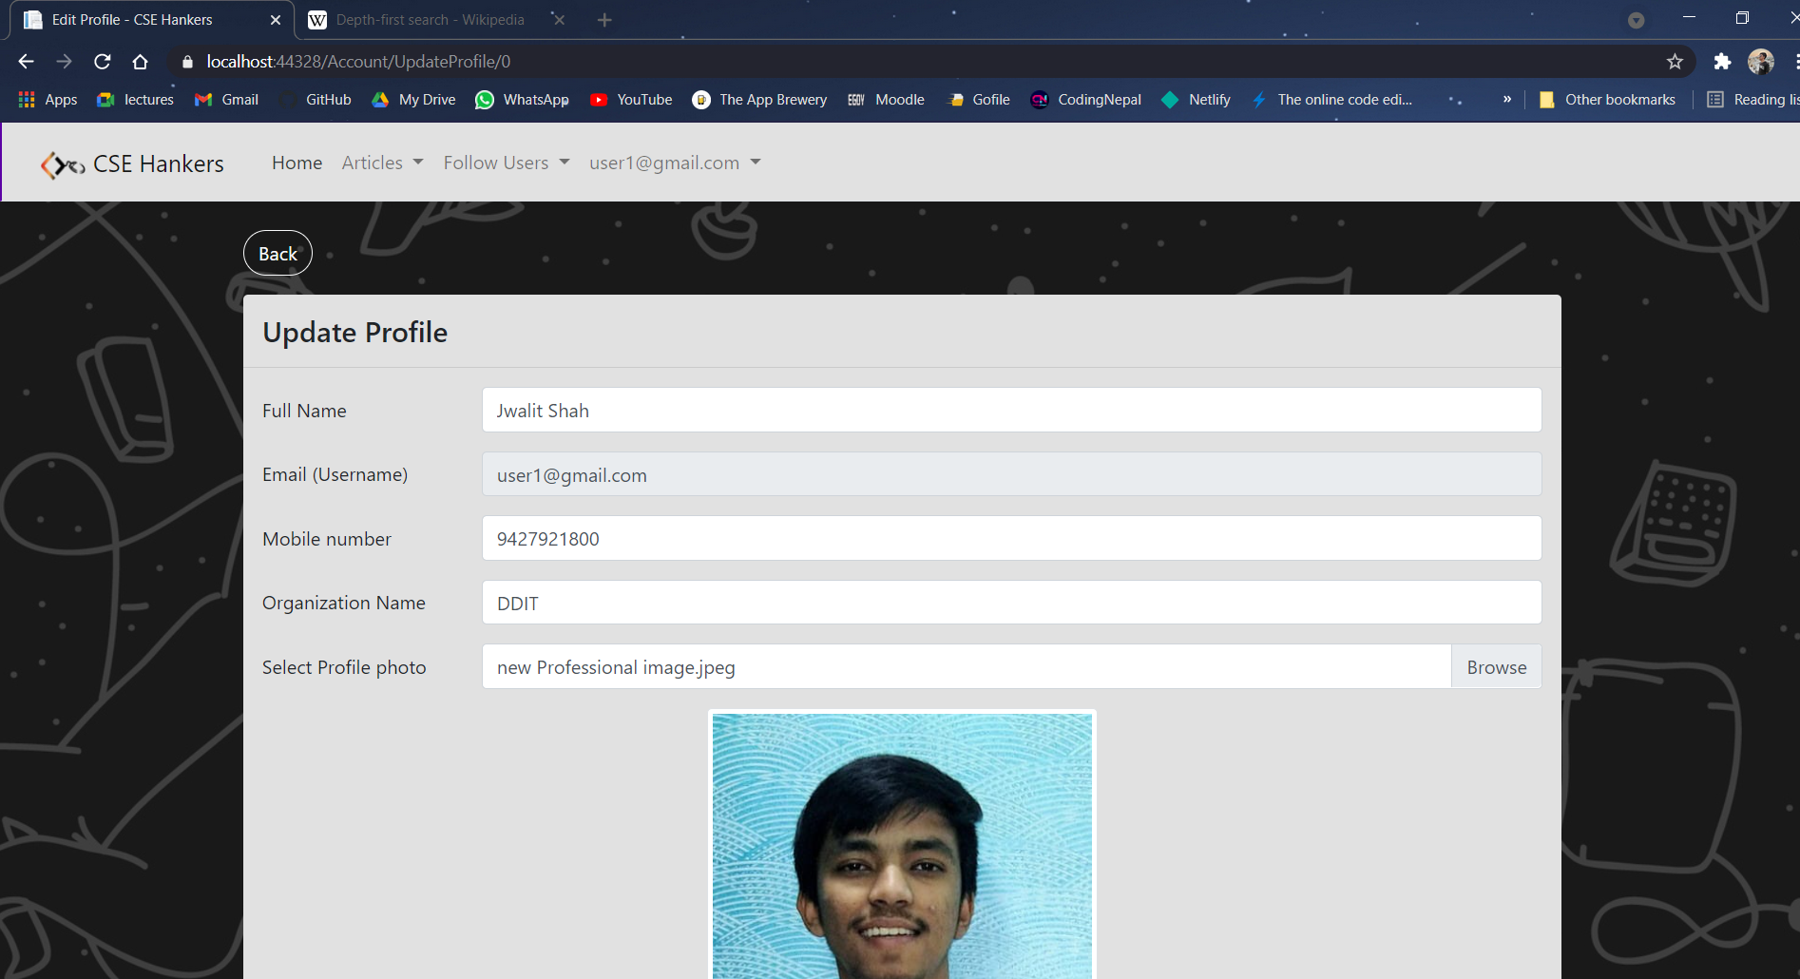

1. **After updating profile**

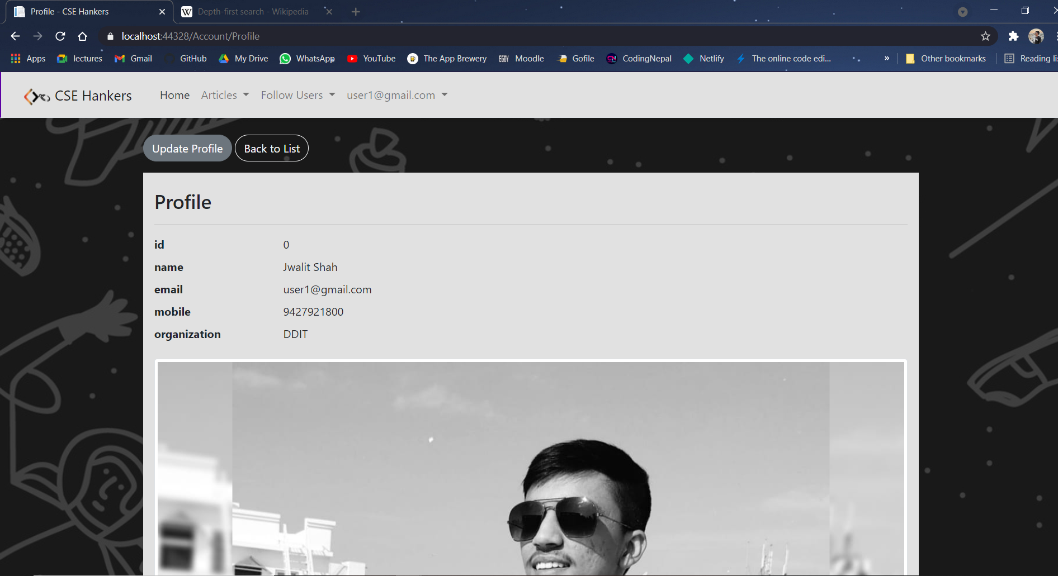

1. **Logout**

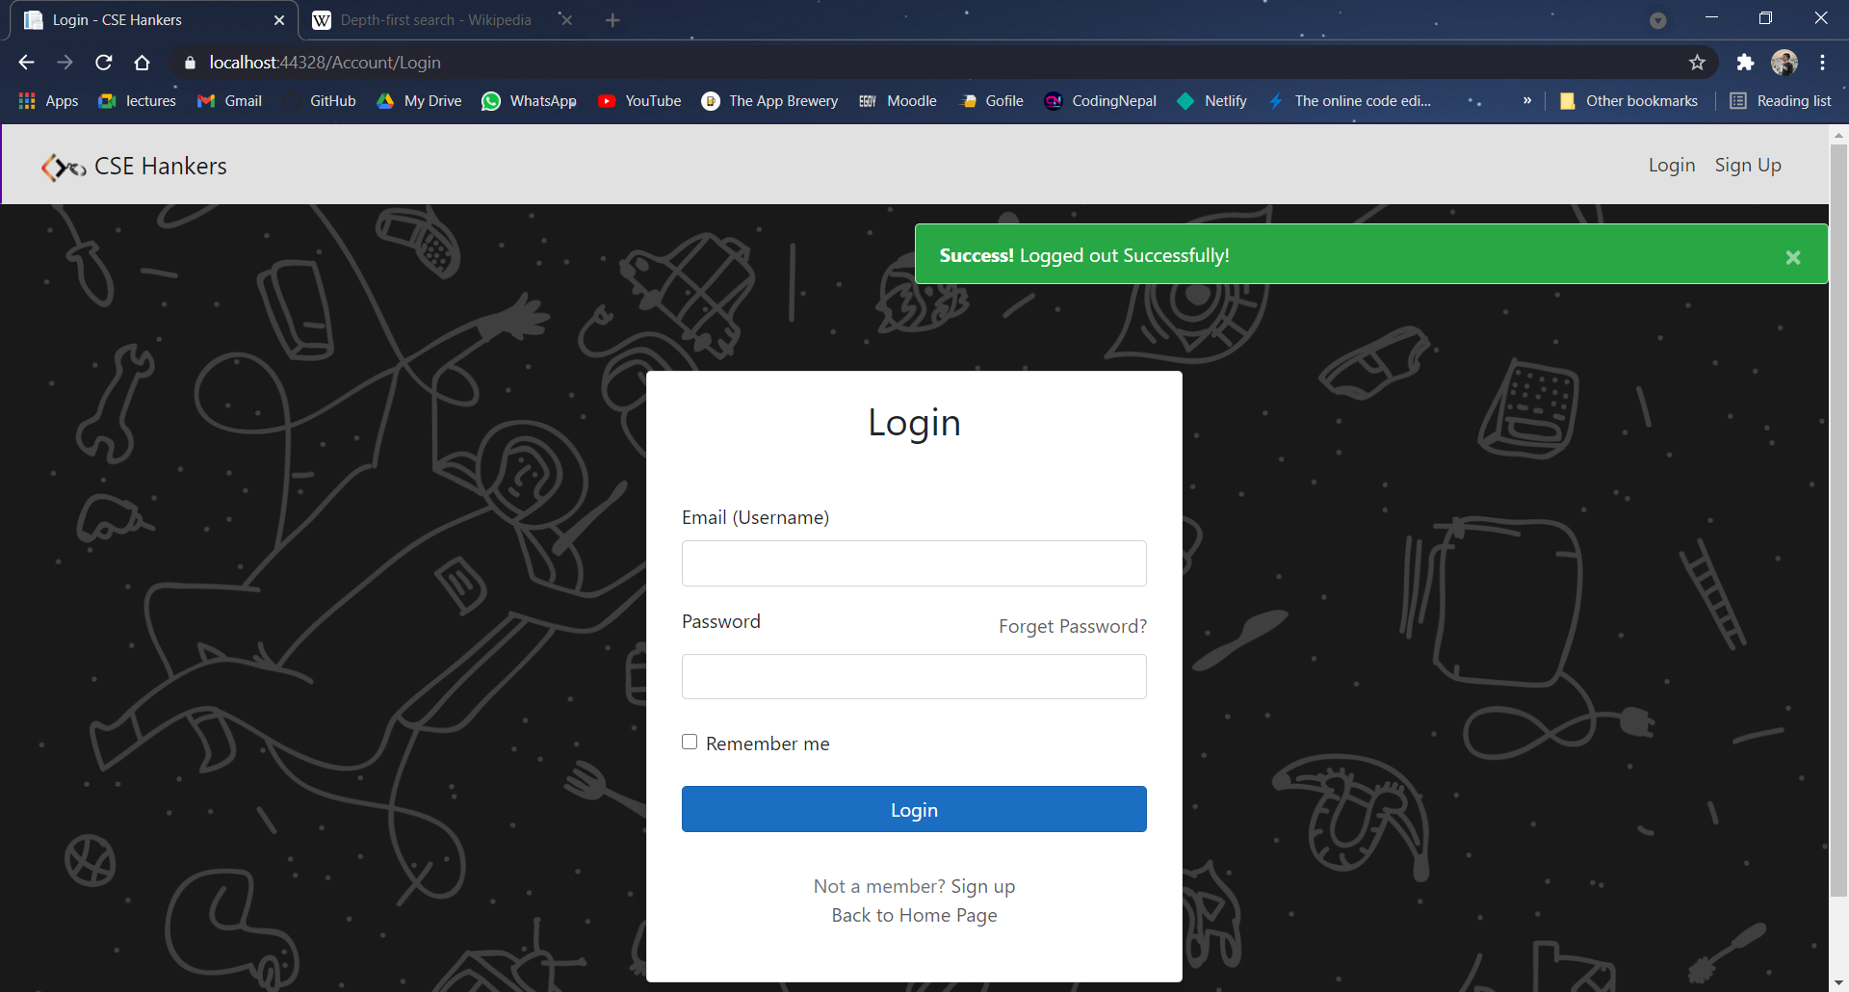

# **Conclusion**

**Functionalities implemented successfully:**

* Login by user.
* Registration by user.
* Follow user
* Unfollow user
* Publish article
* Update article details
* View articles list of own
* View followed user’s articles list
* View article
* Delete article
* Give comment on article
* Update comment
* Like article
* Dislike article
* View other user’s profile
* Update own profile
* Upload the profile picture
* Logout from the system

# **Limitation and Future Extensions**

## **Limitations**

* User can’t login in case if password is not known
* User cannot change their username after registration

## **Functionalities not implemented**

* Forgot password
* Add, update, delete, view Questions
* Add, update, view Answers
* Like/ Dislike to answers

## **Possible future extensions**

* Users can update their old password to the new password using forgot password in case if password is not known.
* Users can publish and manage the questions posted on the forum.
* Users can give answers to the questions posted on the forum
* Users can provide their feedback to posted answers by liking or disliking the answers.
* Users can give their feedback to the system administrator.

# **Bibliography**

To build this project we have taken references from following websites,

- [Quora](https://www.quora.com/)

- [Article Services](https://www.infoq.com/articles/dotnet-core-article-second-series/)

- [C-Sharp corner](https://www.c-sharpcorner.com/)

- [Stack overflow](https://stackoverflow.com/)